| **BLOG-BYTE Progress File-8** |
| --- |

**Categories and Tags - Frontend**

1. **Category page**
2. **Create category**
3. **Category read delete and messages**
4. **Tag Component**

**_______________________________________________________**

# **TASK-1 Category page**

**STEPS :**

* In **frontend,** go to **pages,admin** modify **index.js**.
* Adding Bootstrap4 list. <https://getbootstrap.com/docs/4.0/components/list-group/>

|  |
| --- |

* 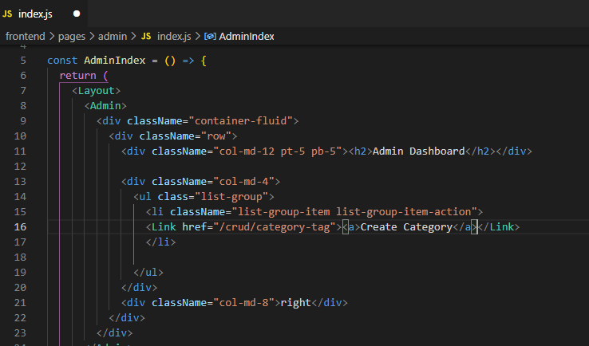
* In **pages,** go to **admin** create a new folder **crud** add file **category-tag.js**.Add Manage Categories section
* 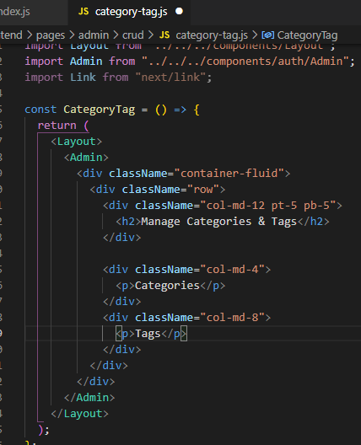
* Login as admin, to dashboard and see create categories here.

|  |
| --- |

* Click on create category and it will redirect to page. <http://localhost:3000/admin/crud/category-tag>

|  |
| --- |

**=>Category Page created Task Completed… :)**

# **TASK-2 Create category**

**STEPS :**

* In **front end, actions,** create a new file **category.js**. Adding create action here.
* 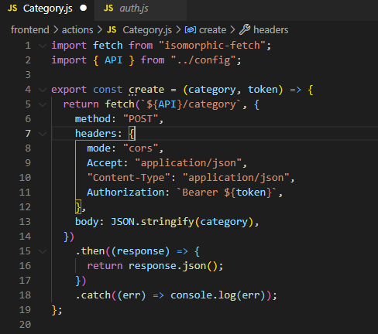
* In **front end, components,** create a new folder **crud** add file **category.js**.
* Creating category component.
* 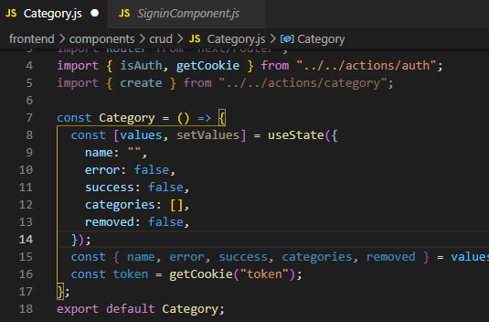
* Creating category from.
* 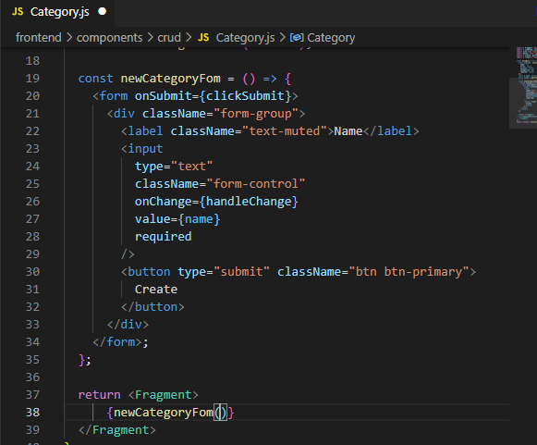
* Creating required functions for from.
* 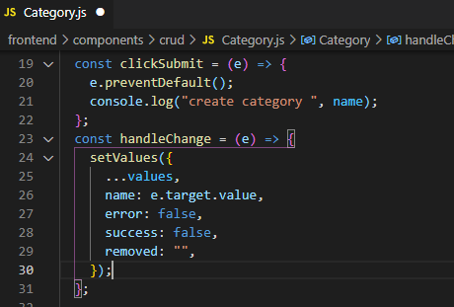
* Sending category info to backend.
* 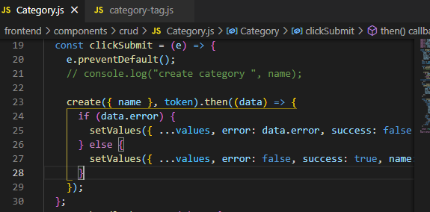
* In **pages,** go to **admin** create a new folder **crud** go to file **category.js**.
* Adding category component here.
* 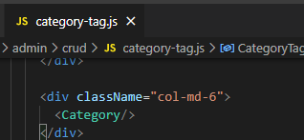
* Create category component <http://localhost:3000/admin/crud/category-tag>

|  |
| --- |

* Create categories here ans see database.

|  |
| --- |

**=>Create Category added, Task Completed… :)**

# **TASK-3**

# **Category read delete and messages**

**STEPS :**

* In **front end, actions,** create a new file **category.js**. Adding some methods here.
* To get all categories.
* 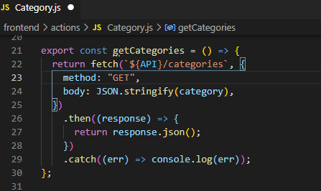
* To get single category
* 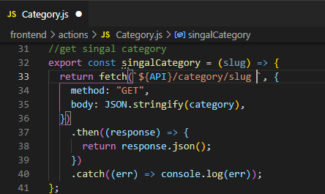
* Remove category
* 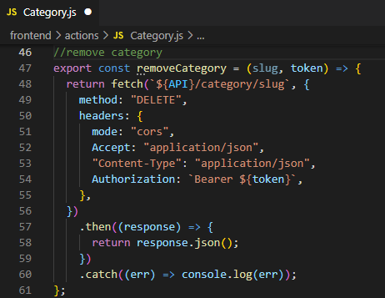
* In **front end, components, crud** go to file **category.js**.
* 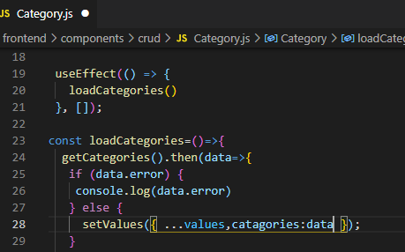
* 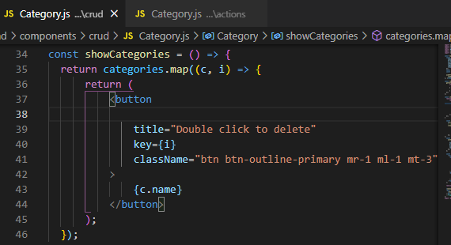
* Now see categories. <http://localhost:3000/admin/crud/category-tag>

|  |
| --- |

* Creating delete categories.
* 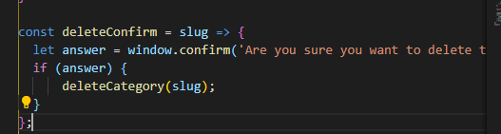
* 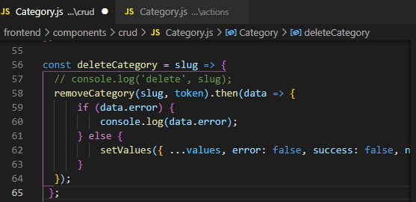
* Double click, we will be prompted for category deletion

|  |
| --- |

* On clicking ok category will be deleted from the list.
* Adding messages.
* 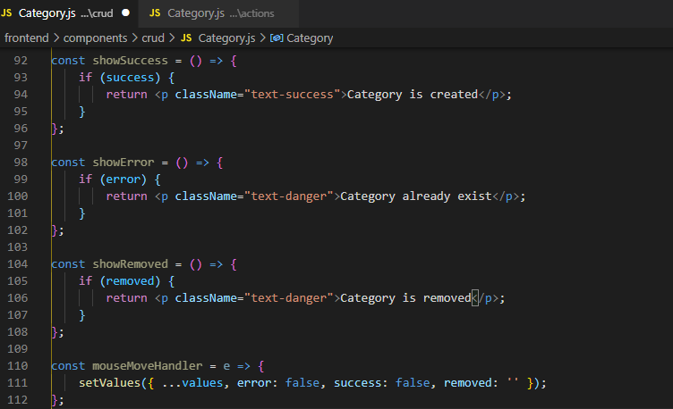
* Some changes.
* 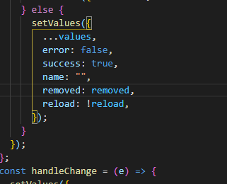
* Displaying messages.
* 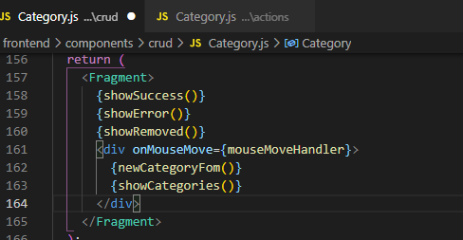

|  |
| --- |

|  |
| --- |

|  |
| --- |

**=>Category list and read, delete msgs added, Task Completed… :)**

# **TASK-4 Tag Component**

**STEPS :**

* In **front end, pages,crud,** go to file **index.js**. Adding tag in list.
* 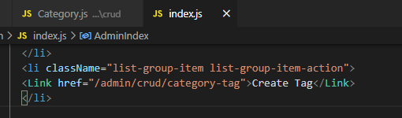

|  |
| --- |

* In **front end, actions,** create a new file **Tag.js**. Adding some methods here.
* To create tag.
* 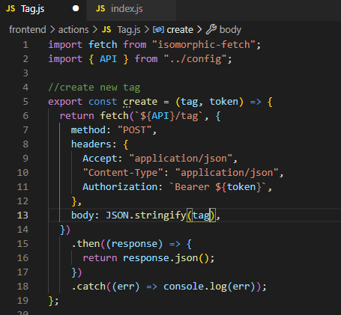
* To get all tag.
* 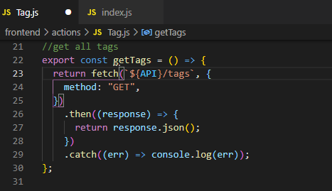
* To get single tag.
* 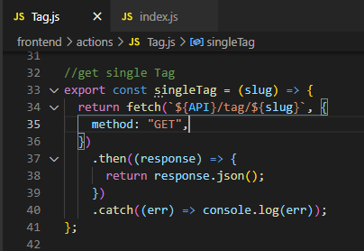
* Remove tag.
* 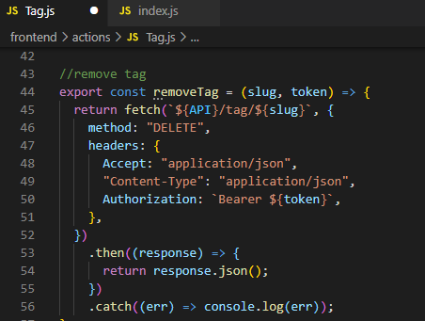
* In **front end, components, crud** create new file **tag.js**.
* Adding tags component.
* 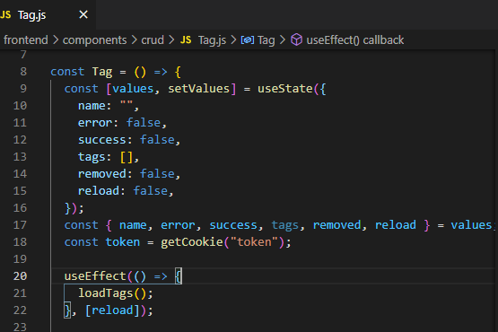
* Load all tags.
* 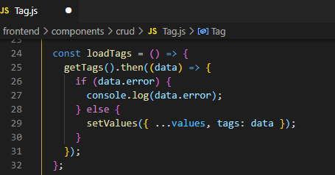
* Show tags.
* 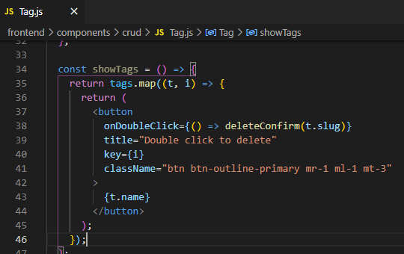
* Delete tag.
* 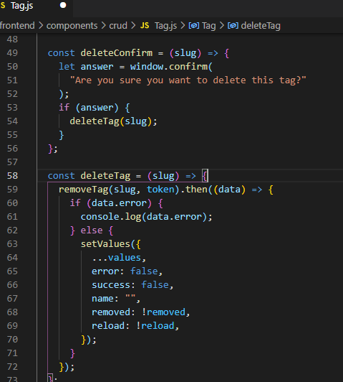
* On Submit method.
* 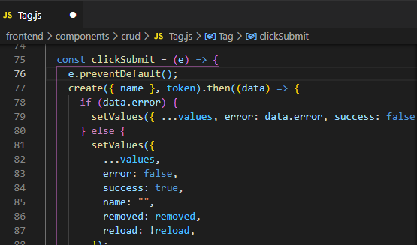
* 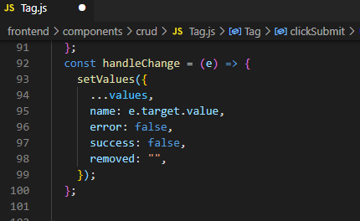
* Adding messages.
* 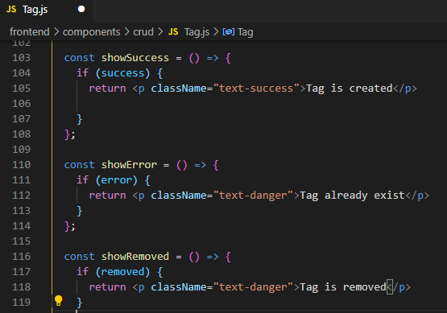
* Displaying tags.
* 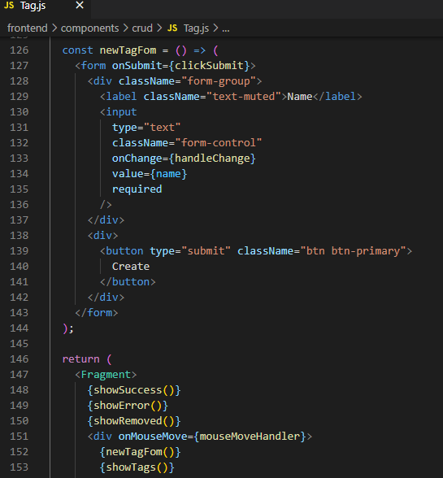
* Creating delete categories.
* 
* 
* Double click, we will be prompted for category deletion

|  |
| --- |

* On clicking ok category will be deleted from the list.
* Adding messages.
* 
* Some changes.
* 
* Displaying messages.
* 
* In **pages,** go to **admin** create a new folder **crud** add file **category-tag.js**.Add tag component here
* 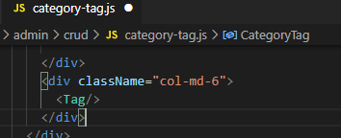
* Now see tags. <http://localhost:3000/admin/crud/category-tag>

|  |
| --- |

|  |
| --- |

|  |
| --- |

**=>Tags component added, Task Completed… :)**